**PROJECT 2: AVERAGE MOVIES BUDGET**

This task given a list of movies. Each movie has two pieces of information:

* The name of the movie
* The budget of the movie

The task is to:

1. Calculate the **average budget** of all the movies.
2. Show which movies spent **more than the average** and how much more.
3. Count how many movies are above the average budget.
4. (Optional) Allow the user to add more movies before doing the calculations.

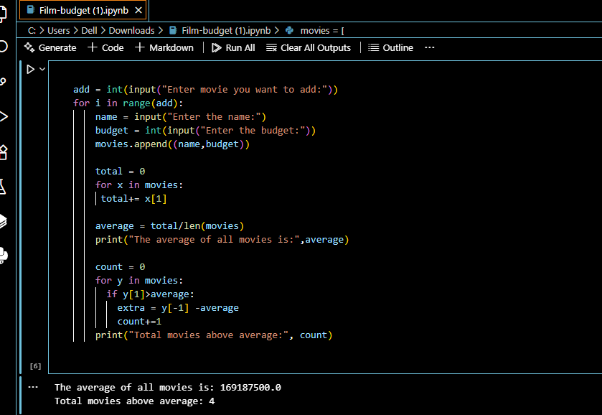

EXPLAINATION:

* First, add up the budget of all movies.
* Divide the total by the number of movies → this gives the **average budget**.
* Go through the list again:
  + If a movie’s budget is **greater than the average**, print the movie name and how much extra it spent.
* Count how many such movies are above the average.